Postal Life Insurance

Department of Post

Software Requirements Specification (SRS)/ Functional Requirements Specification (FRS)
  - India Post Payments Bank (IPPB)

INTERNAL APPROVAL FORM

Project Name: India Post Payments Bank (IPPB)
Version: 1.0
Submitted on:
 | Name | Date
Approved By:
Reviewed By:
Prepared By:

VERSION CONTROL LOG
Version | Date | Prepared By | Remarks
1

Table of Contents

1. Executive Summary 4
2. Project Scope 4
3. Business Requirements 4
4. Functional Requirements Specification 6
4.1 Standing Instructions 6
4.2 IPPB Mobile Banking 7
4.3 IPPB Micro-ATM 8
5. Attachments 9

1. Executive Summary
The purpose of this document is to define the requirements for integrating the Postal Life Insurance (PLI) Insurance Management System (IMS) Billing and Collection Module with India Post Payments Bank (IPPB). The integration will enable premium collection and loan repayment through IPPB’s digital and assisted channels, including Standing Instructions (SI), Mobile Banking (M-Banking), and Micro-ATM.

2. Project Scope
This Integration aims to:
- Facilitate seamless premium and loan repayment transactions.
- Provide real-time policy validation and payment acknowledgment.
- Enhance customer experience through notifications, multilingual support, and offline capabilities.

3. Business Requirements

ID | Functionality | Requirements
FS_IPPB_001 | Standing Instructions (SI) | Customers must be able to register Standing Instructions for PLI/RPLI premium payments through IPPB Mobile App.
FS_IPPB_002 | Standing Instructions (SI) | System should fetch and validate policy details in real-time from IMS using Policy Number and Date of Birth.
FS_IPPB_003 | Standing Instructions (SI) | Customers should be able to set SI validity period and first debit date (configurable options: 5/10/15/20).
FS_IPPB_004 | Standing Instructions (SI) | Provide confirmation of SI registration with reference number and timestamp.
FS_IPPB_005 | Standing Instructions (SI) | Enable auto-renewal of SI post-expiry based on customer consent.
FS_IPPB_006 | Standing Instructions (SI) | Display summary of active SIs on IPPB dashboard.
FS_IPPB_007 | Standing Instructions (SI) | Send push notifications for SI activation, upcoming debit reminders, and expiry alerts.
FS_IPPB_008 | Premium Payment via Mobile Banking | Customers must be able to pay PLI/RPLI premiums and loan repayments through IPPB Mobile App.
FS_IPPB_009 | Premium Payment via Mobile Banking | System should fetch policy/loan details in real-time from IMS using Policy Number/Loan Account and Date of Birth.
FS_IPPB_010 | Premium Payment via Mobile Banking | Provide options for full or partial loan repayment and premium advance payments.
FS_IPPB_011 | Premium Payment via Mobile Banking | Generate and share payment receipts via SMS, Email, and in-app download.
FS_IPPB_012 | Premium Payment via Mobile Banking | Implement real-time premium due alerts and missed payment notifications.
FS_IPPB_013 | Premium Payment via Mobile Banking | Support multi-language interface (via Bhashini) for rural customers.
FS_IPPB_014 | Premium Payment via Mobile Banking | Integrate DigiLocker for document submission for claims or service requests.
FS_IPPB_015 | Assisted Transactions via Micro-ATM | IPPB Agents must be able to process PLI/RPLI premium and loan payments through Micro-ATM.
FS_IPPB_016 | Assisted Transactions via Micro-ATM | Customer authentication should support biometric (fingerprint, iris, face), OTP, or Aadhaar-based verification.
FS_IPPB_017 | Assisted Transactions via Micro-ATM | Enable offline transaction mode with auto-sync when connectivity is restored.
FS_IPPB_018 | Assisted Transactions via Micro-ATM | Standardize biometric authentication across all agents.
FS_IPPB_019 | Assisted Transactions via Micro-ATM | Implement GPS tagging for transaction origin tracking and fraud prevention.

4. Functional Requirements Specification
Use Case Diagram for Integration with IPPB: 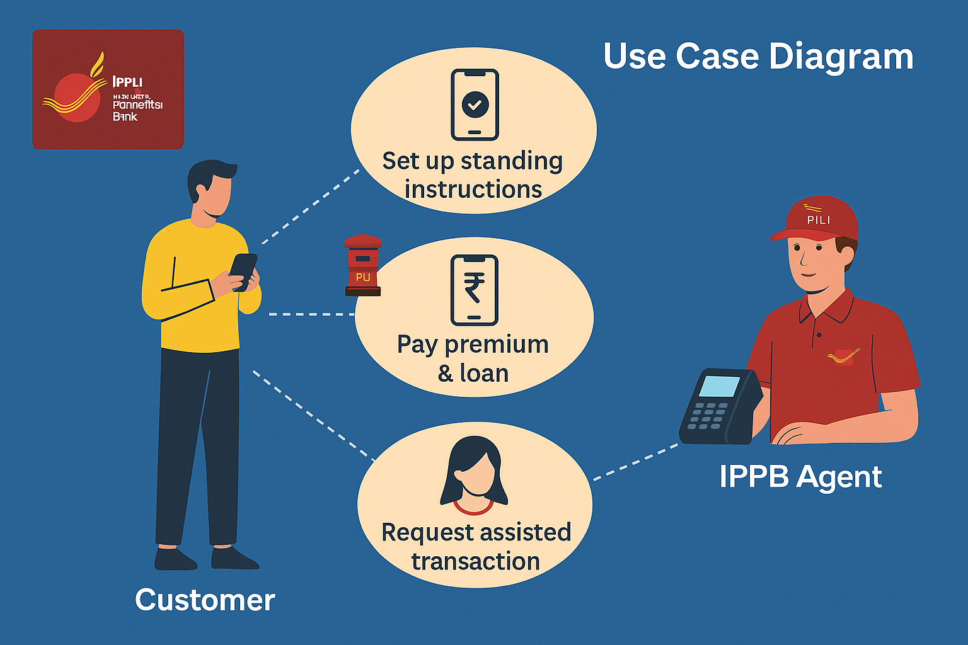

4.1 Standing Instructions
- Purpose: To allow customers to automate recurring premium payments for PLI/RPLI policies through IPPB Mobile App, ensuring timely payments without manual intervention.
- Flow Chart for Standing Instructions
Step 1: Customer logs in to IPPB Mobile App.
- ↓
Step 2: Selects 'Post Office Services' tab from the IPPB dashboard.
- ↓
Step 3: Chooses 'Postal Life Insurance' → 'Standing Instructions'.
- ↓
Step 4: Clicks on 'Add Standing Instruction'.
- ↓
Step 5: Enters PLI/RPLI Policy Number and Date of Birth in the Fetch Policy screen.
- ↓
Step 6: Verifies displayed policy details (Policy No., Product, Frequency, Premium Amount).
- ↓
Step 7: Selects SI Validity Period (From Date, To Date) and First Debit Date (5/10/15/20).
- ↓
Step 8: Confirms entered data and authorizes Standing Instruction via MPIN.
- ↓
Step 9: System displays confirmation message with SI Reference Number and timestamp.

4.2 IPPB Mobile Banking
- Purpose: To enable customers to make one-time premium payments or loan repayments through IPPB Mobile App with instant confirmation and receipt generation.
- Flow Chart for M-banking App:-
Step 1: Customer logs in to IPPB Mobile App.
- ↓
Step 2: Selects 'Post Office Services' → 'Postal Life Insurance'.
- ↓
Step 3: Chooses 'Pay Premium/Loan Repayment' option from the list.
- ↓
Step 4: Reads and accepts on-screen instructions before proceeding.
- ↓
Step 5: Enters Policy Number/Loan Account no. and Date of Birth to fetch policy details for premium payment/Loan repayment
- ↓
Step 6: Verifies premium details and selects number of installments/Loan Repayment full/partial (if applicable).
- ↓
Step 7: Confirms payment details and authorizes transaction via MPIN.
- ↓
Step 8: System processes payment and displays 'Premium Paid/Loan Repayment Successfully' message.
- ↓
Step 9: Customer can view/download receipt or opt for SMS/Email confirmation.

4.3 IPPB Micro-ATM
- Purpose: To provide assisted premium and loan payment services for customers who prefer in-person transactions at Post Offices or through IPPB agents equipped with Micro-ATM.
- Flow Chart for Micro-ATM:-
Step 1: Customer visits Post Office or IPPB Agent equipped with Micro-ATM.
- ↓
Step 2: IPPB Agent logs in to Micro-ATM App and selects 'Post Office Services'.
- ↓
Step 3: Agent searches customer by Account Number, Aadhaar, or Mobile Number.
- ↓
Step 4: Customer authenticates using Fingerprint/OTP/Eye Scan/Face Scan.
- ↓
Step 5: Agent verifies customer’s ID proof (Aadhaar/Passport/Voter ID, etc.).
- ↓
Step 6: Agent selects 'Postal Life Insurance' → 'Pay Premium/Loan Repayment'.
- ↓
Step 7: Explains transaction instructions and obtains customer consent.
- ↓
Step 8: Customer enters Policy Number/Loan Account No. & Date of Birth to fetch policy/Loan details.
- ↓
Step 9: Agent confirms details and proceeds with payment authorization.
- ↓
Step 10: System authenticates transaction and displays 'Premium Paid/Loan Repayment Successfully' message.
- ↓
Step 11: Receipt is generated with options for SMS, Email, and Download.

5. Attachments
The following documents can be referred.

